Unit, Integration, and System Testing Report
Project: Electronics Store
Course: Software Testing
Student: Jurgen Hila

1. Introduction
This document presents the unit testing, integration testing, and system testing activities performed for the Electronics Store project.
The goal of this testing effort is to verify:
- Correct behavior of individual classes (unit testing),
- Correct interaction between multiple classes (integration testing),
- Correct behavior of the system as a whole (system testing).
Testing was implemented using JUnit 5 and executed in IntelliJ IDEA.

2. Scope of Testing and Team Split
The assignment requires writing unit tests for all classes in a package, excluding the view package.
The selected package for unit testing is the Model package.
Because this is a team project, the Model package was divided between two team members.

Classes tested in this report (my responsibility):
- Model.Bill
- Model.UniqueIDGenerator
- Model.Items.Item
- Model.Exceptions
  - AlreadyExistingException
  - InvalidUsernameException
  - InvalidPasswordException
  - InsufficientStockException
The remaining Model classes under Model.Users were tested by the other team member.
Together, the team achieves full unit test coverage of the Model package.

3. Unit Testing

3.1 Definition
Unit testing verifies the behavior of individual classes and methods in isolation, without involving external systems such as UI or databases.

3.2 Unit Testing Implementation
Unit tests were written using JUnit 5 and organized under the test source root:
src/test/java/UnitTesting/ModelTest

Each test focuses on a single class, validating:
- Constructors
- Getters and setters
- Business rules
- Exception behavior
- Data consistency

3.3 Tested Classes and Test Objectives

3.3.1 Item
- Constructor initializes all fields correctly
- Getter and setter methods update values correctly
- Purchase date format is valid
- Object serialization and deserialization preserve state

3.3.2 Bill
- Adding items updates stock correctly
- Removing items restores stock
- Revenue, cost, and profit calculations are correct

3.3.3 UniqueIDGenerator
- Generated IDs are unique
- ID format is correct
- Sequence wrap-around logic is executed correctly

3.3.4 Exceptions
Each exception class was tested to verify:
- The exception stores the provided message correctly
- The exception type behaves as expected (checked vs unchecked)

3.4 Unit Test Execution Results
Unit tests were executed by running the package:
UnitTesting.ModelTest

Results:
- Total tests executed: 11
- Tests passed: 11
- Failures: 0
All unit tests passed successfully, confirming correct behavior of the tested Model classes.

4. Integration Testing

4.1 Definition
Integration testing verifies that multiple classes work correctly together, focusing on interactions between components.

4.2 Integration Testing Implementation
Integration tests were implemented in a separate package:
src/test/java/IntegrationTesting

This ensures a clear separation between unit tests and integration tests.

4.3 Integration Test Scenarios
The following interactions were tested:

Bill + Item Integration
- Adding an item to a bill decreases stock
- Removing an item restores stock
- Bill item list updates correctly

Bill Calculations with Multiple Items
- Revenue is calculated correctly
- Cost is calculated correctly
- Profit is calculated correctly

Bill Output
- Printed bill output contains essential information such as:
  - Cashier details
  - Item names
  - Total amount
These tests verify that Model classes collaborate correctly and produce consistent results.

5. System Testing

5.1 Definition
System testing validates the behavior of the complete system against functional requirements.
Unlike unit and integration testing, system testing is typically manual.

5.2 System Testing Approach
System testing was performed manually by running the application and simulating real user scenarios.

5.3 Example System Test Scenario
- Launch the Electronics Store application
- Log in as a cashier or admin user
- Create a new bill
- Add multiple items with valid quantities
- Verify stock updates correctly
- Verify bill totals and printed output
- Remove an item and verify stock restoration
- Complete the transaction
Expected result:
The system correctly manages inventory, calculates totals, and displays accurate bill information.

Actual result:
The system behaves as expected in all tested scenarios.
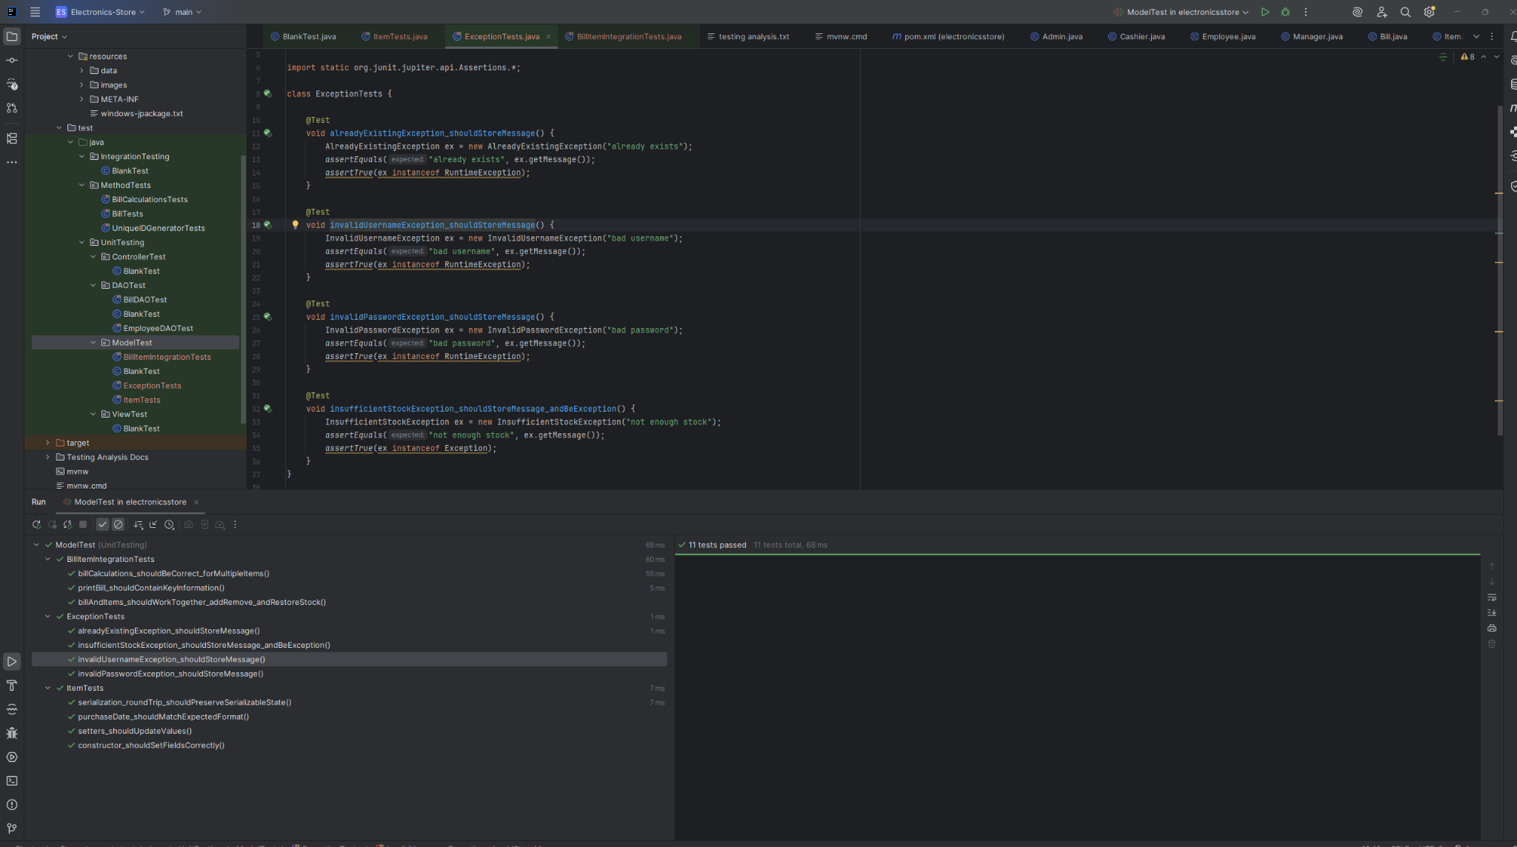

6. Conclusion
All required testing activities were successfully completed:
- Unit tests validate individual Model classes
- Integration tests validate interactions between Model components
- System testing validates end-to-end application behavior
The test results confirm that the tested portion of the Model package is stable, correct, and reliable.
The team-based division of responsibilities ensured complete coverage of the selected package while maintaining clear documentation and traceability.

